AFL Specialist Academy
Handbook
2022

AFL Academy Coordinator – Kimberley Boulton (Teaching Year 7/8 AFL)
Kimberley.bowey@education.wa.edu.au

AFL Specialist Teacher – Jarrod Wayne (Teaching Year 9/10 AFL)
Jarrod.wayne@education.wa.edu.au

AFL ACADEMY HANDBOOK

History:
The AFL Specialist Program was originally developed as an engagement program to increase attendance of students at education risk by supporting positive interactions in the school with the added incentive of being involved in the most played sport in Australia.
Aims:
Since its introduction, the AFL Specialist Program has grown into a successful venture with AFL Specialist groups from Years 7 – 10, roughly 110 students, and pathways into Year 11 and 12. In 2020, the program was been rebranded as the AFL Academy, with a specific focus on encouraging our students to maintain a high standards with regards to behaviour, attendance, and achievement both within the Academy and the school as a whole. Our academy links in closely with our school business plan and the schoolwide values in STARR (Safe, Trustworthy, Achieving, Respect, Resilience).
Whilst our main focus is on developing students understanding and skills to become competitive athletes on the AFL field, we also emphasise the importance of other roles within the AFL Community that are of significant value to the game as a whole. Within our theoretical programs in Years 9 and 10 we provide opportunities for our students to develop the knowledge and skills required to become effective coaches, umpires, or admin staff within the AFL Community, and are available to help students network with the wider AFL Community to persue these pathways. We proudly encourage our students to become leaders within our schooling community and beyond, empowering them to be confident to make decisions of their own on and off the field, and to be accountable for these decisions.
For students driven to succeed at an elite level we have strong links with AFL and AFLW clubs, as well as, community districts to provide pathways into the WAFL and WAFLW systems. We have had some very successful students play at the highest level in the WAFL and we are looking forward to the day that one of our students becomes part of the 1% that make it into the AFL.

Our Philosophy:
The pedagogical goals behind the development of the AFL Specialist Program reflect a holistic approach to education. We strive to produce quality footballers, academically achieving students and outstanding people. Our AFL Specialist staff are driven by a passion for education and football with a focus on bringing them both together. This passion focused our attention on the need for students to be successful, confident and independent learners.
At the heart of all AFL activities and programs is the promotion of the following core values:
- Striving for Excellence
- Individual Development
- Teamwork and Cooperation
- Trust
- Respect
- Self Acceptance and Respect of Self
- Respect and Concern for Personal Rights
- Personal Responsibility and Responsibility to the Group
- Accountability of Self and Accountability within Groups
The AFL Academy focuses on the latest developments in the AFL with a strong emphasis on game performance. Students engage in meaningful learning experiences, which are relevant to the current development objectives of themselves and the group.
Being a skill based sport our main focus is on developing the cores skills of kicking, handpassing and marking using industry relevant techniques and strategies. The academy has an emphasis on developing game sense in students to better understand how to play the game, as well as, building an understanding of strategies and tactics, and when to apply them to the benefit of their team on game days.
The academy focuses on teamwork and building quality, workable group dynamics and relationships. This aspect is further exemplified by the participation on teams in various events and competitions throughout the year. Students’ high level of focus, engagement and achievement in the AFL Specialist Academy activities are a direct product of the strong and mutually respectful relationships built with others in the Academy as well as the AFL Specialist staff at Cecil Andrews College.
The program not only has a focus on developing quality AFL people but also on developing the literacy and numeracy skills required to gain a good education at school. AFL Specialist staff use football as the vehicle to deliver literacy and numeracy tasks which help students achieve an OLNA to help with graduation requirements. On top of the literacy and numeracy focus AFL Specialist staff are exposing students to the STEM revolution and how Science, Technology, Engineering and Mathematics is used in the AFL industry, this opens up opportunities for students to experience jobs related to STEM which makes up 70% of the new jobs created in employment.
Overall, our aim is to provide students with a holistic education which will hold them in good sted no matter if they plan on becoming an AFL player, going to University, studying at TAFE, or entering the workforce.
As previously stated our AFL Academy activities promote positive behavior, which is inextricably linked to our own Cecil Andrews College schoolwide expectations and values:

S – Safe
Follow rules and procedures, identify and report hazards, keep school environment tidy, engages in safe behaviour on the football field
T - Trustworthy
Be honest, be reliable, show care and respect, keep to your word, follow instructions, move equipment and belongings in appropriate manner
A – Achieving
Participate to you best ability, take pride, attend regularly, encourage/help others in positive manner, seek and apply feedback, be receptive to others, set individual goals
R - Respect
Use manners and polite language, establish positive relationships, follow instructions, allow others to learn, return equipment how you found it, help others at any opportunity
R – Resilience
Ask for help, bounce back, positively resolve conflict, engage in healthy coping habits, be accountable for actions

AFL Specialist Staff:

Kimberley Boulton – AFL Academy Coordinator
kimberley.bowey@education.wa.edu.au
Kim is an experienced teacher who currently plays in the WAFLW for East Fremantle Football Club, she is a Level 2 Accredited Coach with experience coaching in the WA State Talent Academy, East Fremantle WAFLW Reserves Competition and the Kirby Bentley Indigenous Girls Competition. Additionally, she is a Level 1 Accredited Umpire with over 7 years experience umpiring in the East Fremantle District Junior League, and over 5 years experience umpiring in the Western Australian Amateur Mens Football League. She uses a wide range of strategies to engage students in learning and is an AFL School Ambassador. She has a particular interest in developing a female AFL program within the College in the coming years, and has connections with WAFL, WAFLW and AFLW clubs, which can further the development of our students by engaging them in pathways outside of the educational setting.

Jarrod Wayne – AFL Specialist Teacher
Jarrod.wayne@education.wa.edu.au
Jarrod is an excellent teacher who has a wealth of football knowledge and experience. Previously teaching at SEDA College, coaching at Thornlie Junior Football Club for 4 years, and strength and conditioning coaching for Perth Demon’s Development Squad for 2 years, Jarrod brings an indepth understanding of the intricacies of football, as well as connections with the wider AFL Community. He is committed to finding the best learning outcomes for each of our students, and uses a range of teaching strategies to do so. Additionally, Jarrod’s qualifications enable him provide a platform for our upperschool students to continue their involvement in football whilst they progress with their studies in our Year 11 and 12 Certificate courses at Cecil Andrews College.

Student Expecations:
All students enrolled in the AFL Academy are held accountable for their behaviour within the Academy and the school as a whole. We encourage all our students to develop individual responsibility and responsibility to the group. We believe that the development of this ethos makes for a cohesive and successful group as well as a confident, mature young members of our community.
Students are required to:
- Wear appropriate school uniform (Please note: AFL Academy students are required to change from their school shirt [or AFL Academy shirt] into their AFL Academy singlet for each practical session and to change back to their College or AFL Academy shirt at the conclusion of each practical session).
- Wear appropriate AFL attire to all AFL classes and games (students are encouraged to bring football boots and mouthguards to school for practical AFL classes)
- Attend additional training sessions when required
- Attend all school based AFL matches
- Attend to all academic responsibilities and strive for their best
- Be role models in all classes
- Participate in all AFL activities
- Participate in fundraising as required
- Meet all course and assessment requirements
Trials:
Trials for the AFL Specilaist Academy are held in the Gymnasium and on the College oval.
Trials will involve;
- Basic exercise testing as completed by the AFL Draft Combine
- Basic skills analysis for kicking, handballing and marking
- Game sense activities
- An expression of interest form completed and returned prior to the trial on the specified due date.
Please contact a AFL staff member for an Expression of Interest form.

Selection Criteria for Year 7 AFL Specialist Academy:
Students will be ranked and final selection based on the following data:
- Trial
- Academic results in Physical Education and teacher judgements.
- Attendance and Behaviour Data.

The Head of Department - Physical Education in consultation with the subject teacher will determine which students will be invited to join the AFL Specialist Academy. New students (enrolled after the commencement of the year) who would like to join the AFL Specialist Academy will be assessed on an individual basis by the AFL Coordinator. If no places are available then a waiting list will be created.
Selection Criteria for Year 8, 9 and 10 AFL Specialist Academy:
Students will be selected to continue from year to year or new students added to the AFL Academy based on the following key criteria. With the initial ranking determined from criteria one and further fine tuning based on the additional criteria items.
- Trial
- Attendance and Behaviour Data.
- Participation in extra-curricular activities.

The Head of Department - The coordinator in consultation with the subject teacher, will determine which students will be invited to join the AFL Specialist Academy.
New students (enrolled after the commencement of the year) who would like to join the AFL Specialist Academy will be assessed on an individual basis by the AFL Academy Coordinator. If no places are available then a waiting list will be created.
Probation Period:
All students who enroll into the academy complete a period of probation. This occurs for their first semester in the program. This enables us to evaluate their suitability over a period of time. During this period we are assessing the students’ skills acquisition, willingness to engage, commitment to the academy and their ability to work as a team member or an individual. Students who are not suited to the academy are returned to the mainstream cohort. Students will be given plenty of encouragement prior to this taking place and parents will be contacted before any movement occurs. At any time students or parents may discuss their progress with any member of the AFL Specialist Academy staff.

Identification of Students NOT Maintaining High Standards:
Students that are not maintaining high standards of academic achievement and performance in the AFL Specialist Academy can be identified through one or more of the following criteria:
- Poor performance or achievement in 2 or more assessment items.
- Repeated incidents of assigned work not being completed to the best of their ability.
- Deterioration of behaviour standards that impacts on their class performance and/or the performance of other members of the class.
Students will be identified by the teacher for potential removal through the AFL Coordinator.
Removal from the Academy:
Students who are experiencing difficulties meeting the course requirements will be placed on an appraisal program that involves a further probationary period. During this time issues with the student progress will be identified to the student, with appropriate strategies for improvement. If at the end of the probationary period the student has been unable to show significant improvement the student will be removed from the academy and returned to the mainstream cohort. Students will be given plenty of encouragement prior to this taking place and parents will be contacted before any movement occurs. At any time students or parents may discuss their progress with any member of the AFL Specialist Academy staff.
Review Process and Removal from Class or Academy:
The following procedures should be implemented when looking at reviewing students’ placement in a class or the program.
- Identify student(s) to be reviewed and discuss intention with the AFL Specialist Coordinator
- A letter is to be sent home indicating the areas of concern that have been identified and how this may constitute a breach of the conditions for maintaining a position in the AFL Specialist Academy.
- The student will be given a negotiated period of time to show improvement prior to any further review.
- A meeting with the parent and student should be arranged to explain the circumstances and make sure that they understand the requirement to improve and the impending removal from the program if this cannot be achieved.
Mid Year Review:
At the conclusion of Semester One all student positions in the AFL Specialist Academy will be reviewed with reference to Semester One reports. This will provide an opportunity for additional students to be added to classes if room is available.
Extra Curricular Activities:

We offer extensive extra-curricular programs within the AFL Specialist Academy. Our students have the opportunity to be involved with the Year 8/9 Eagles Schoolboys Cup, the Year 8/9 Freo Dockers Schoolgirls Cup, the Year 8/9 Female Freo Dockers Cup Lightning Carnival, the Year 10/11/12 Male Simply Energy Cup, and the Year 10/11/12 Female Freo Dockers Cup. Additionally an annual lightning carnival is run for each year group from Years 7 – 10 at differing times throughout the year. There are also various competitions we are involved in each year which are day to day events.
Every two years we take students across to Melbourne to experience the game at the home of football. We take 20-30 students across with a range of educational activities arrange along with some tourist activities and finally a range of AFL related activities. Students find the experience extremely worthwhile and enjoy the responsibility of travelling with a large group.
We are also involved in various events throughout the year in conjunction with AFL clubs such as indigenous leadership program, nutrition and goal setting.

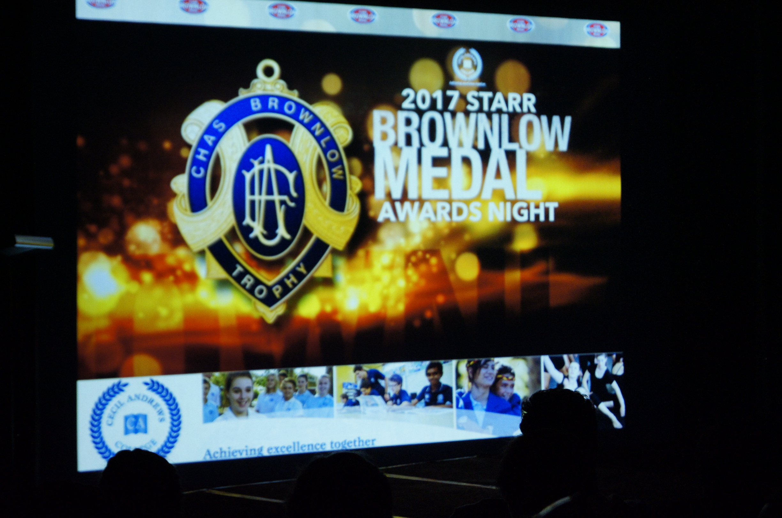
STARR Brownlow Medal Awards:
In conjunction with our positive behaviour program we have a Specialist AFL Brownlow Medal Awards night. At this event a student from each year group is awarded the coverted Replica Brownlow Medal, it is awarded to the student with the most votes polled for the year.
3, 2 and 1 votes are given for theory and practical based session each week by specialist teachers under the following categories:
Safe, Trustworthy, Achieve, Respect, Resilience
Further prizes are given for the highest polling player under each of the above headings.
Students can also poll Bonus Brownlow Votes with their general classroom teachers if they are maintaining high academic standards and showing positive behaviours.
Overall the awards night is a great way to celebrate some of the achievements of our specialist students throughout the year and also a great way to induct our graduating students from Year 12 into the Hall of Fame.

2021 Brownlow Medal Winners:
Year 7 Year 8 Year 9 Year 10
Jayden Guidera Koby Millington Taiwaio Morrison Israel Bucktin

Facebook Page:
The College Facebook page allows us to keep parents up to date with information on uniforms, upcoming events, fixtures for games and photos from events.
Search “Cecil Andrews College” click “Like” and follow the events of the year.

AFL Specialist Gameday Uniform:
All students are required to have correct school uniform for excursions and games.
Game attire includes:
- Navy blue shorts
- Navy blue socks
- Football boots
- Mouthguard
- AFL Jersey is provided by the College for gameday
Students are to change into AFL attire at the beginning of games.
Fees:
As a specialist course additional fees apply. You will be notified of these at the commencement of each year. It is a requirement of the course that all fees are paid by the commencement of Semester Two or that a payment plan is in place.
Parent Support Group:
The parent support group is an integral part of the ongoing success of this academy. Parent support is a vital aspect to all children’s success.
Scholarship Program:
At the end of each year the AFL staff nominates one student per year in year 7, 8, 9 and 10 to receive the AFL Scholarship. This scholarship covers the students AFL fees for the following year. Students who receive these scholarships are identified for their pursuits of excellence in all aspects of AFL.

Pastoral Care:
All students involved in the AFL Academy have access to all elements of pastoral care within the school. In addition to that all members of the AFL staff are extremely supportive of each young person in the program.
Each child is monitored for issues of concern and students’ suitability to the program is constantly reviewed. Any issue that arises is dealt with in consultation with the student to keep them on their pathway of success.
At the end of semester one, Mrs Kimberley Boulton will review all specialist students’ reports to assess their academic achievement. During the course of the year any issues concerning academic progress are referred to the HOLA and/or relevant Academy staff who put strategies in place to support the individual child’s achievements. At any time parents or students are encouraged to discuss any concerns they have academically or socially with AFL staff.

My child and I acknowledge and accept all the conditions of the AFL Specialist Academy.
I will adhere to the guidelines and instructions laid out in this document.

Parents Name: ______________________

Parents Signature: ____________________

Parents Contact Ph: ___________________

Students Name: ______________________

Students Signature: ___________________

Date: _______________________________

